Making that Big Decision

Common misconceptions about being published:
If I get a publisher, I’ll be rich.
Statistics say that less than 5% of authors make a living off their writing.
If I get a publisher, I won’t have to market or build a platform.
These days, publishers are looking for authors who already have a following and
social media platform and who will work to market their own books along with the publisher.
If I get a publisher, I’ll be set for future books.
Even some of the biggest authors have different publishers for different books.
A contract today doesn’t guarantee contracts in the future.
If I get a publisher, I’ll be a “real” author.
Many of us want the validation of being accepted by a name everyone recognizes.
However, being rejected by a big-name publisher does not mean you’re not a great writer.
Think of it like the Olympics. In the US, there are thousands of good gymna sts, and hundreds of elite gymnasts, but only a handful get to go to the Olympics. Does that mean all the rest were not good? Of course not. It was a matter of only having a few slots, and having to choose who would fit those slots best.

Questions to Help You Consider Your Options:
What is your main purpose in writing?
Ministry
If you go traditional, you might find more people in your target audience through the publisher’s established market.
If you self-pub, you have the option of giving away your book in multiple formats. With a publisher, they have the rights and you can typically only give away copies you’ve bought at the author rate.

Personal
If it’s a memoir for your family get-together, or a very personal story with a select niche audience, print-on-demand is an option authors have not had until previously, but works perfectly for these kinds of books.
Make Money
With a traditional publisher, you might get a hefty advance, and if your books does well, royalties once your advance earns out. Their larger platform would normally result in many more sales.
Self-pubbing means you are 100% responsible to sell your book. However, if it sells well, you receive a much higher percentage of the profits. Some big-name authors are turning to self-pubbing because they already have their audience, so why not make more money doing it themselves?

If you had a book, would you rather:
- Possibly sell less copies, but make more profit on them? (Self-pubbing)
- Possibly sell more copies, but make less profit on them? (Traditional Publishing)
- Not be responsible for creating and selling your book - but it’s not one that would be accepted by a large publisher? (Small Publisher)
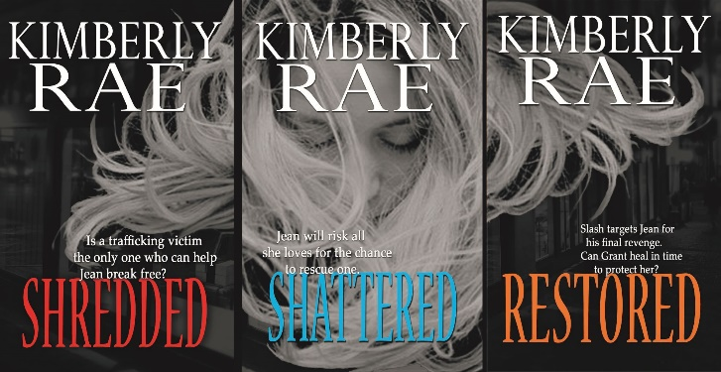
How much control do you want on
Future manuscript changes?
Cover design?
Back matter, front matter?
Future books in the series (content)?
If none: Traditional Publishing
If some: Small Publisher or Hired Help with Self-Pubbing
If much or all: Self-Pub

There is still of course the issue of needing to create a high-quality, well-edited book with a great cover, so if you don’t have interest in finding editors or designing your own covers or hiring someone to do so, traditional publishing would be the way to go.
www.kimberlyrae.com
Get more info on writing at https://kimberlyrae.com/for-writers/

