- Why Should An Author Start A Blog?
Reasons Why Writers/Authors Don’t Start A Blog
Perhaps a friend has suggested you should start a blog, and you reply:
- I don’t have time.
- The time I do have, I want to be writing my work in progress.
- I wouldn’t know what to write.
- I don’t know how.
6 Reasons An Author Should Consider Blogging
These are valid reasons. But, perhaps the better question is, “Why should you, as an author, consider blogging?”
- Potential agent/publisher. From reading your blog, an agent or publisher can discover everything from your writing style to your dedication and commitment to diligently produce a body of work. These traits show you have the fortitude and follow through to produce a completed book. The blog also shows you can complete self-imposed deadlines. Think of a blog as a part of your writing resume.
- Building a platform. When submitting your work for publication, agents and publishers want to know you already have readers in place willing to buy your book. But, what if you don’t have a completed book yet? Start a blog. Get a following. If you haven’t heard the word “Platform” yet, I highly recommend a book of the same name by Michael Hyatt. He shares many ways to build a platform.
- Create content for your readers, even before you publish. What do you write? How do you draw your readers to, well, read? Look at the themes or topics your book shares with your readers. Then write about those themes. If you write romance, share how your grandparents met. If you write about mystery, tell your potential reader about your favorite Agatha Christie novel or how Perry Mason captivated you and why. Creating this content will not only allow your readers to get to know you, but they will get used to your writing style and hopefully want to read more.
- Sales funnel. Once your book is published, you can broadcast your first novel on your blog. Provide a sales page to purchase your book or add your Amazon link in a blog post. Your blog/website can also share your availability to speak, providing yet another revenue stream.
- Posting a blog on social media lends credibility. When you post your blog on Facebook, the box surrounding the blog title and featured image appears. This not only looks professional but newsworthy. You are not a news outlet but may look like one. This lends credibility to your blog rather than just typing a post with text only. See the example below:
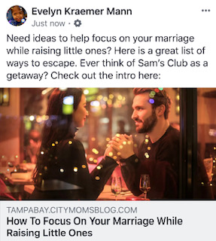
- You can get discovered. In late 2016, I received an email asking about my son’s lethal form of dwarfism. The email was from the producers at The Learning Channel. They wanted to feature my son on one of their programs. When I asked how they heard about my son, the TLC representative said she found me via my blog. The producers, located in England, searched on the internet, and found my blog. The SEO, the blog writing, and my website combined to peak the interest of TLC. Now my son’s story has been broadcasted in the U.S. and worldwide. All from someone finding my blog.

Blog Testimonials
Many authors recommend a blog as a means to gain an audience and future readers of your book.
“… I think blogging is an author’s best marketing tool.” Anne R. Allen, Author of eight comic mysteries.
“The more time you spend blogging, the more value you build for your readers over time, and the more they find you. Your efforts snowball.” Jane Friedman, a columnist for Publishers Weekly and author of The Business of Being a Writer.
Molly Wizenburg’s popular food blog, Orangette, was a platform that helped her sell her first book, A Homemade Life, to a publisher because she had a large readership.
For all of The Blogging Guide blogs, go to https://www.almostanauthor.com/category/craft/blogging/

- Content Ideas
Using Your Book As Inspiration
If you are an author, write down the themes in your book. For my memoir, Miracle In My Living Room, a few themes are hope, problem pregnancy, and surviving a dire diagnosis. Each of these themes can be shared as a blog post.
Write Ideas Down Write (Right) Away
My ideas for blogging come from everyday life. When a thought comes to mind, I jot it down quickly to remember the details. I use iPhone notes to keep track of ideas. I also use an old-fashioned pen and paper; however, it is too easy to lose a piece of paper. Using the recorder on my iPhone is another way to help remember blog ideas.
Free Write
What content to create is a conundrum we all face as authors. Pick a day and a time to write free from distractions. Many times, you face a blank page as a cricket chirps in the background. Just start typing. Free write whatever comes to mind. Often times, I will end up writing 2–3 topics in one sitting. I flush out the most developed topic and save the other topics for another blog.
How To Find Topics
Use a calendar of Events and Holidays as great idea starters for your blog.
www. Apples4theteacher.com/holidays has a list of events and holidays to choose from. January 8th is National Clean Off Your Desk Day. Write a blog about how you keep organized as an author. Post a picture of your organized desk. You could also engage your readers by asking them to share their tips.
April 10th is National Library Day. Blog about your local library. Contact them and offer to do a book signing to promote National Library Day.
April 12th is D.E.A.R–Drop Everything And Read Day. Share an excerpt of your book in a blog post.
April 14th is International Day of Laughter Day. Share humorous excerpts from your book.
April 28 is Sense of Smell Day. Share excerpts from your book which describe a sense of smell. Offer tips on how to write a scene using the five senses. Engage your readers to submit a short story highlighting a sense of smell and award the winner a copy of your book.
Buddy Up
Find another blogger in your same genre and buddy up to brainstorm content ideas. Once written, you can promote each other’s blog on your social media platforms. This is a great way to build a friendship and also share each other’s audience.

Ask Your Audience
Asking your audience is a great way to not only engage with your readers but allows them into your process. What content would they want to read?
Jessica Osborn-Houser of JJburry.com offered her readers an opportunity to choose which blog they wanted to read. The choices offered were:
- Using Sentence Variation
- Adding details with phrases
- How to write book reviews
Her readers voted to learn how to write books reviews by 63%. She posted her poll on Twitter, but you can use Facebook to post a poll. Once the voted on blog posts, you have an instant audience interested in reading it.
How To Poll Your Audience
You can find the option to poll in a group only. Facebook removed the option to poll in your own personal Facebook feed. Here’s how to post in a group.
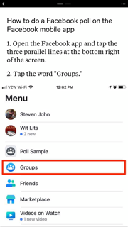
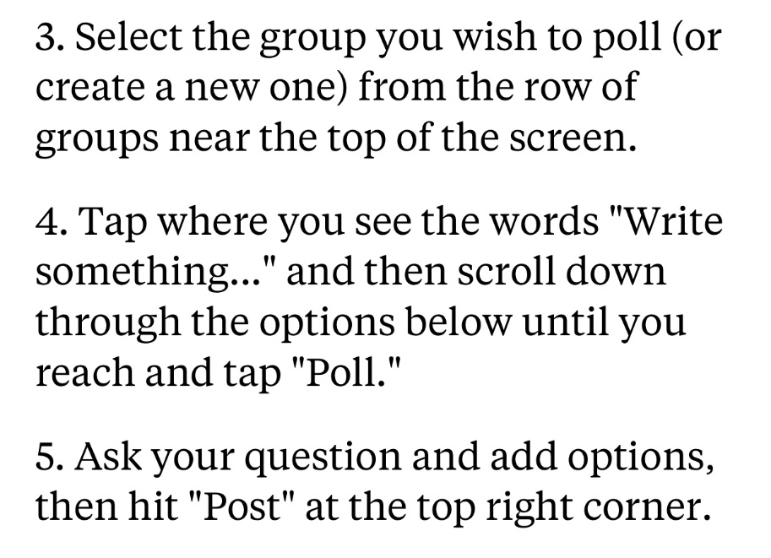
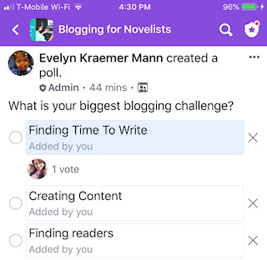
- Increase Your Blog Visibility For 2019
You pour out your heart and passion out on the page crafting your blog for the world to see. Satisfied with your words, you publish and wait. Days later, you view your blogs statistics to find few readers. How do you gain readers and raise visibility?
The following tips suggest ways to help you share your passion to a wider audience:
Do your Facebook family and friends know you have a blog? Tell them. It can be as simple as, “Hey, did you know I have a blog? Check it out here.” And then add your link. Note: You can share your blog on your Facebook feed if it is not sales oriented. If you want to sell your book or product within Facebook, use your separate author page or your business page.
You can also share a specific blog post on your Facebook feed and author/business pages. Don’t just share your blog post, tell the reader why they would want to read your blog. Many people won’t stop scrolling to read your blog unless you give them a reason to click on your link. Give the reader the hook of your post right up front.
Definition: Hook–this is a literary technique that grabs the reader’s attention within the first few sentences. https://literarydevices.net/hook/
Carol Graham posted her blog in the Facebook group Blogging Lounge with this hook: Could you live off the grid for a year with little human contact–if offered $100,000? She then posted her blog titled: What Would You Sacrifice for a Huge Reward? Did Carol’s hook get your attention? Check out her blog here: https://batteredhope.blogspot.com/2019/02/what-would-you-sacrifice-for-huge-reward.html?m=1
My hook in the blog post on How To Focus On Your Marriage: Ever think of Sam’s Club as a getaway?
Posting in Facebook Groups
Are you posting your blog in appropriate groups? Is your blog themed toward mothers? Find a moms group in Facebook like Coffee & Motherhood with 51K+ members. Do you have a travel blog? Find a travel group like the Facebook group, Travel Bloggers with 4.5K members. Does your blog offer writing tips for authors? Try posting your tips in the Authors group with almost 40K members. Find your niche in Facebook groups is a key to finding your audience.
- 200 million people are members of meaningful Facebook groups.**
Many Facebook groups only allow you to post your blog on certain days only. And other groups allow for free posting without having a set time to post within the group. Here are a few examples.
Specific Post Days:
BTR–Blogger’s + Instagram Community: https://www.facebook.com/groups/btrcommunity
Christian Moms Who Write (Share Wednesday): https://www.facebook.com/groups/christianmomswhowrite
Free Post:
Blogging Lounge: https://www.facebook.com/groups/1377737912484876
Christian Bloggers café: https://www.facebook.com/groups/212862818752603
When you post in a group, be sure to hook your reader. Posting the link with the title only may not be enough to encourage your audience to click to your blog. Also, interact with other bloggers to build your tribe.
Sharing In Group Discussions
Do you share your blog topics in group discussions? Have you ever been in a group discussion and thought, “I wrote about this issue in my blog.” As long as the group allows it, post your blog in the discussion feed. Use your blog post to share your passion and build your audience. The sales opportunity will hopefully come after you build relationships.
Note: Be sensitive to group rules if your blog post is sales focused or offers affiliate links.
For more blogging tips go to: https://www.almostanauthor.com/category/craft/blogging/

