Self-Publish for Less than $20 on Amazon

You’re finally done with your book. Now what? You want to self publish, but don’t want to spend thousands of dollars and end up with hundreds of copies molding in your basement.
These days, thanks to Amazon’s print-on-demand KDP (Kindle Direct Publishing) there is a much better option. I know the learning curve can be overwhelming, so I’m going to walk you through the process step by step.

Step 1: Do you have an Amazon account? If not, get one.
Step 2: Go to kdp.amazon.com. You’ll see the option for signing in. You’ll use your Amazon sign in information to access this.
Once you have signed in, Amazon’s Kindle Direct Publishing page will appear.

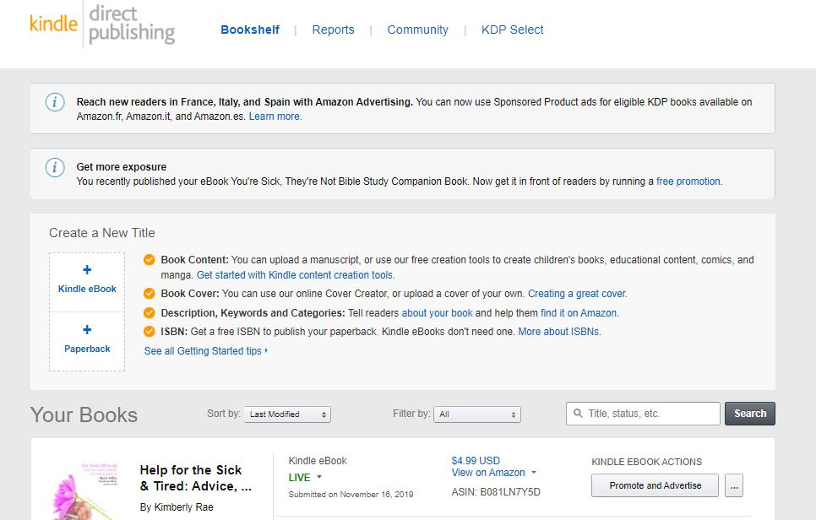

Step 3: See the “Create a New Title” box? You want to click on either the Kindle ebook option or the Paperback option, whichever your book will be. (If you’re going to do both, it doesn’t matter which one you do first, they’ll sync together.)
Step 4: We’re going to start with the Paperback. Once you click that, a new page will appear asking questions about your book for the Amazon webpage for your book. Fill in the blanks, then click save and continue (or save as draft if you want to finish it later).

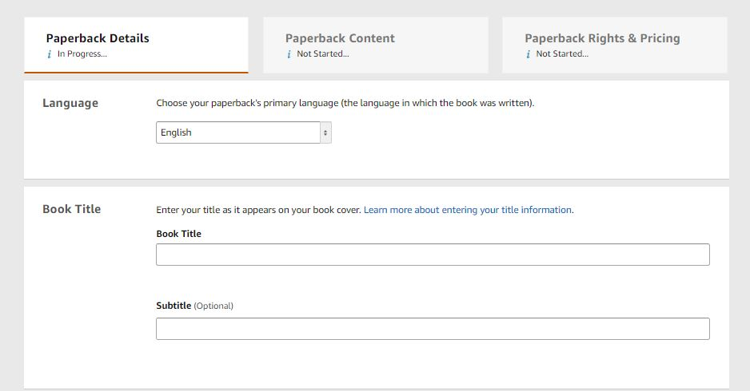

Step 5: Page 2 for your book will appear. This page can feel really complicated, but it gets easier the more you do it. Some of the option that will appear:
Assign ISBN. I use the free ISBN and have never had any trouble with it. Once you get that ISBN number, it needs to go on the copyright page of your book interior also.
Publication Date: can ignore
Step 6: Print Options: here you get to choose what size you want your book to be, what kind of paper, if you want your clover glossy or matte, and if you want bleed or not. (Bleed means your graphics go all the way to the edge of the page, such as in a children’s book with illustrations. No bleed means you have a white margin on the edges.)
Step 7: Next you’ll see the Manuscript section. The hardest part (in my opinion) of self-publishing is formatting your book to the required specifications. For Amazon, they make it easier by providing templates for you, so once you know your book size and type of paper, you can click “download a KDP template” (in blue among the text) and it will guide you to download a template you can copy and paste your book content into. Once the interior of your book is ready, you’ll want to save it as a PDF (if not, the formatting will go pretty crazy when you upload it) and then upload the PDF.
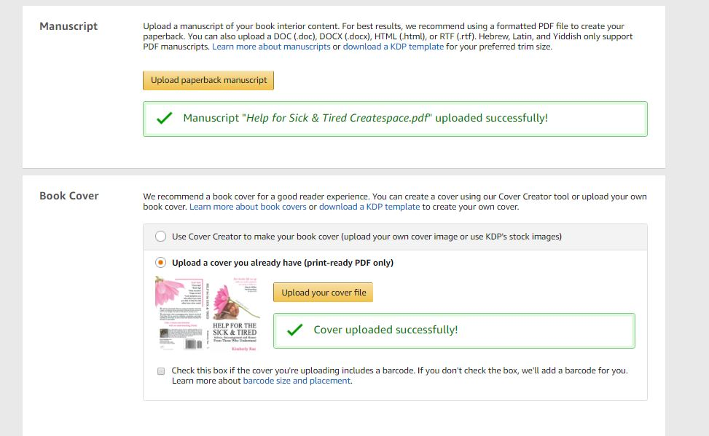
Step 8: The cover is a similar process. If you have no interest in or ability to make your own cover, you can click “Use Cover Creator” and that will lead you to Amazon’s templates for you to simply paste your information into and wallah, your cover is ready.
If you are making your own cover, you’ll want to “download a KDP template” for your cover just like you did for the interior, only this one will need to know how many pages your interior is so it can make the spine the right width.
Once your cover is ready, upload the PDF.
Step 9: Now the fun part! At the bottom of the page you’ll click, “Launch Previewer.” Then you might as well go do something else, because it will feel like it takes ages for Amazon to configure everything. Once it does, your book will appear in all its glory. You will be able to see the cover and the each page of the interior as if you were looking through it in book form. Here is where Amazon will notify you of obvious errors that need fixing, or when you look through, you’ll probably find some of your own. If you need to fix things, close out, fix stuff or save it as a draft to fix later, then upload your corrected book and launch the previewer again. Do this as many times as it takes to get your book the way you want it.
Step 10: The third page is about money. If this is your new book and all yours, you can click worldwide rights. Then it’s on to pricing. How much do you want to charge for your book? The site will calculate how much royalty you will make on each book based on different sale prices, so you can play around with this part until you find the amount you want.
The Expanded Distribution option means they can sell your book to other booksellers at a lower cost. I’d recommend it.
Step 11: Order a proof. At the bottom of the page you can order a proof copy of your book. The amount the book costs is the same cost per book whether you buy one copy or one thousand (that’s one thing I love about print-on-demand). The shipping will be about $4 for a proof copy, but shipping per book goes down the more copies you order.
When you get the proof in the mail, congratulations!!!!! There’s nothing like holding your book in your hands. Then you can check over it with a fine tooth comb, and hopefully have some good editor-types read through it as well to catch what you missed. When all changes have been made, you can go through the upload process again, launch the previewer, and either order another proof copy, or decide you’re ready.
Step 12: When your book is all you want it to be and ready to release it into the world, hit that last button, “Publish your paperback book.” Now, this is the final gauntlet. Amazon will do a final check of printing capability. Usually within 48 hours, you’ll get an email from amazon saying either your book has been published and is now available on Amazon, or there were problems that need to be fixed before it can be published.
Step 13: Order copies! Once your book is published, you can order author copies (at your author rate) by going into your KDP site again and there on the first page on the right side next to your book you’ll see a button: “Order Author Copies.”
And you’re all set…unless you want to do an e-book also… (next page)

Self-Publishing an ebook on Amazon

Same as paperback except a few important differences.
Your title and description info will transfer from the paperback, so you won’t have to do that twice. You don’t need an ISBN for an ebook. When it asks you to upload the manuscript, you’re going to want to upload your book in Word with very little formatting, so that Amazon can adapt it to different sized readers, such as Kindle, tablet, and phone. So keep is as simple as possible.

For your cover, you only upload a jpg and just the front cover.

KDP Select
Personally, I recommend putting your books into KDP select. To do this, you’re saying your books are exclusively with Amazon (as far as digital sellers, this doesn’t mean you can’t sell books at bookstores or personally). If you’re with KDP select, your book will be offered in the Kindle Unlimited program, so people who are with Kindle Unlimited can read your book for free, and Amazon pays you for pages read. Also, with KDP select, you have the option every 90 days of up to 5 days of offering your book for free. This may sound counter productive, but it’s a great way to market your book for free. The more people who read it, the more they’ll talk about it or want to buy it for others. Free exposure, in my opinion, has always been worth it, especially if you market your free days well (see other handout with the FB group links).

Okay, you’re on your way! I hope this helps you get your books published with little cost and less hassle.

Kimberly Rae
Know your Worth, Change the World
www.kimberlyrae.com

